Author’s Template for Full Papers
for the 6th International BBB Congresses 2021
Author A¹, Author B²
¹ Organization/Institution, Country
² Organization/Institution, Country
lead.author@institution.com (Lead author email address)
Abstract. The abstract should summarize the contents of the paper and should contain at least 70 at most 150 words. It should be set in 10-point font size and should be inset 1.0 cm from the right and left margins. There should be two blank (10-point) lines before and after the abstract. This document is in the required format…

Keywords: Include a list of not more than 5 keywords, for example: building information modeling, BIM, high-rise buildings, water infrastructure (separated by commas).

Introduction
This file must be used as a template for the full paper in English language. Please submit the final PDF and DOCX files of your paper until 15th June 2021 using the online submission system at:
https://www.conftool.net/bbb-kongress2021/
The length of the paper should be between 15.000 and 20.000 characters, including spaces. The paper should have between 8 and maximum 12 pages including tables, figures, and references.

General Instructions
Guidelines for the preparation and submission of full papers are given in this document. Although manuscripts will be reviewed and may be returned to authors for revisions before publication, initial submissions should be made in the final form, assuming that no revisions shall be necessary.
Please ensure that the margins of the page are set for 2.5 cm at the top, bottom, right and left margins. The text should be justified to occupy the full line width, so that the right margin is not ragged, with words hyphenated as appropriate.

First Page
The first page should include the title, information on the author(s), and the short abstract with keywords. Subsequently authors can begin with the introduction.
Styles. We advise using the styles defined in the template. If you are using other software, please use the following layout guide described below. Submitted papers must follow the layout template.
Fonts. Use 12-point type for the name(s) of the author(s) and 10-point type for institutions, address(es), the abstract and keywords. For the main text, please use 11-point type and single-line spacing. The font style must be Calibri. Italic type may be used to emphasize words in running text. Bold type and underlining should be avoided.
Headings. Headings are limited to three levels and should be capitalized (i.e., nouns, verbs, and all other words except articles, prepositions, and conjunctions should be set with an initial capital) and should, with the exception of the title, be aligned to the left. Words joined by a hyphen are subject to a special rule. If the first word can stand alone, the second word should be capitalized. The font sizes are given in Table 1.
Table 1: Font sizes in Tables should be 10 point with bold headings.
Heading level | Example | Font size and style
Title (centred) | Author’s Template… | 18 point, normal
1st-level heading | 1 Introduction | 13 point, bold
2nd-level heading | 2.1 First Page | 12 point, bold
3rd-level heading | Headings. Text follows … | 11 point, bold

Figures and Tables
Please create graphs and line drawings electronically and insert them electronically into the finished document. Characters in the figures should not be smaller than Calibri (or equivalent) 8 pt. Photographs should also be inserted electronically into the document. The resolution should be 150x150 dpi (dots per inch) for photographs and 300x300 dpi for drawings.
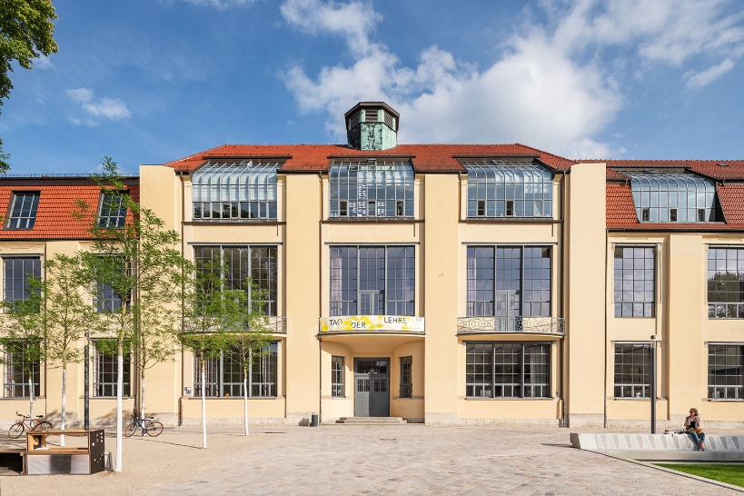
Tables should have borders at top and bottom of each line. Text in tables should be Calibri 10 pt. Bold can be used for the headings of table columns or lines. Each table and image will count as 250 words regardless of size.
Figure 1. This is a figure.
All figures and tables must be cited in the text and inserted near the location where they are first cited. Provide a figure number and caption below each figure or photograph and a table number and caption above each table. Numbering should be done consecutively in the order in which they appear. The captions of figures and tables should be written in Calibri 10-point type.
The conference proceedings will be prepared in both electronic and printed versions. As the printed version will be in black and white, authors are requested to check and ensure the presentation of illustrations and figures in both colour and black and white.

Equations
Insert all equations using the equation editor (integrated in Microsoft Word). Equations should be referenced with a number shown in brackets (1), to the right of each equation.
$$ax=b$$ | (1)

Units
SI units shall be primarily used. For decimal separator use a dot ‘.’ (not a comma ‘ , ‘ ). US Customary units can be shown in parentheses additionally.

Submissions of Full Papers Elsewhere
The content of this paper must not have been or be subsequently published in another journal, compendium, or conference, nor should it be under consideration by other conferences or journals while being reviewed for this Congress.

Author Contribution
By submitting this paper to the BBB Congress, the author(s) take public responsibility for the work they have submitted.

References
References should be listed in a dedicated section at the end of the paper. They should be listed in the order in which they appear in the paper and provided in the Harvard referencing style, e.g. (Belsky et al. 2005).
More information on the Harvard referencing style can be obtained at:
https://www.mendeley.com/guides/harvard-citation-guide
The list of references is headed “References” and should be placed at the end of your contribution, in front of the appendix, if one exists. Please do not insert a page break before the list of references.
Belsky, M., Sacks, R., Brilakis, I. (2016). Semantic Enrichment for Building Information Modeling. Computer-Aided Civil and Infrastructure Engineering 31 (4), 261–274.
Borrmann, A., König, M., Koch, C., Beetz, J. (Eds.) (2018). Building Information Modeling. Technology Foundations and Industry Practice. Cham, Springer.
See, R., Karlshoej, J., Davis, D. (2012). An Integrated Process for Delivering IFC Based Data Exchange. IUG 2012/08. https://standards.buildingsmart.org/documents/IDM/IDM_guide-IntegratedProcess-2012_09.pdf (accessed 15/2/2021).

